PE Funding

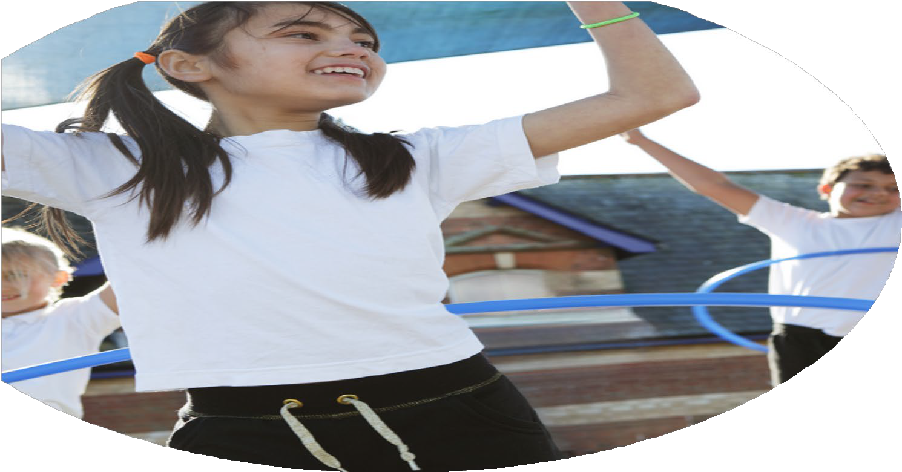

Evaluation Form

**Commissioned by**

**Created by**

Images courtesy of Youth Sport Trust

**We recommend that you start by reflecting on the impact of current provision and reviewing your previous spend**

|  |  |  |  |
| --- | --- | --- | --- |
| What went well? | How do you know? | What didn’t go well? | How do you know? |
| Consolidated the partnership with Elite Kids Coaching for staff CPD, competitions and curriculum lessons.  PE Pro App was introduced to help with planning and progression across the curriculum. | Five external competitions were entered. Elite Kids Coaching provided a range of activities across our school’s Fitness Fortnight for all children.  Staff used the app for every PE lesson and they requested for the app to be renewed for 24/25. |  |  |

|  |  |
| --- | --- |
| What are your plans for 2024/25? | How are you going to action and achieve these plans? |
| Intent | Implementation |
| To ensure that the school is fully resourced for all PE lessons and after-school clubs.  To provide a range of extra-curricular clubs for children from Years 1-6.  To ensure that new staff are provided with CPD opportunities in PE.  To improve performance in external sporting competitions by using funding to prepare in PE lessons and after school.  For all children to access a variety of activities across our annual Fitness Fortnight. | Liaise with School Business Manager and Head Teacher to spend budgeted sports funding amount on resources that are required for PE lessons and clubs. To regularly assess the quality and quantity of kit in the PE cupboard.  All staff to hold either a lunchtime of after-school club for children in an area of their choosing.  Ensure new staff have one term’s worth of CPD training from Elite Kids Coaching and to provide after-school training events with ACES.  Subject Leader to create a yearly timetable for sporting competitions. Clubs and lessons to prepare children for the competitions.  Subject Leader to organize the Fitness Fortnight timetable for all children in July. |

|  |  |
| --- | --- |
| What impact/intended impact/sustainability are you  expecting? | How will you know? What **evidence** do you have or  expect to have? |
| Staff to be confident in the teaching of PE.  An increased percentage of pupils from Years 1-6 attending extra-curricular clubs.  Increased performance in level 2 and 3 external sporting competitions. | High quality lessons, drop-in evidence and staff/pupil feedback.  Subject Leader to analyse the attendance for after-school clubs and to invite targeted children throughout the year.  Results of competitions. |

|  |  |
| --- | --- |
| What **impact/sustainability** have you seen? | What **evidence** do you have? |
| Staff have become more confident in the teaching of PE.  There is an increase from 57% of pupils attending extra-curricular clubs the previous year.  Improved performance in external level 2 sporting competitions. | Staff/pupil voice and subject leader drop-ins and feedback.  Club registers and after-school club data.  Victories in tag rugby (Year 5), football (Year 4), dodgeball (Key Stage 1) and cricket (Year 3) competitions. Girls’ football competition third place (out of 10 schools) for Year 6. Year 6 tag rugby – second place. |