**Lion Class**

**Parents Letter**

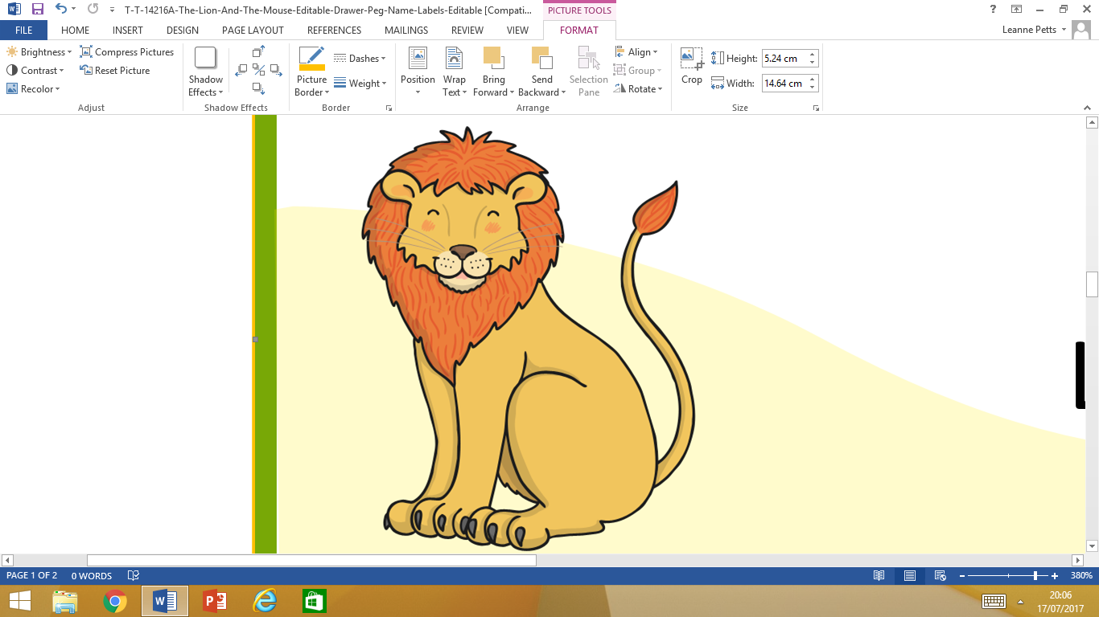

Term 3a

**Hot and sunny weather**

As the warm weather approaches, we recommend that children bring in a named summer hat and sunglasses, so that they stay protected from the sun when they play out**. Every child needs to bring a named water bottle.**

When the weather does become warmer you may want to put sun cream in your child’s bags. We are kindly asking that they only bring in roll on/stick sun cream as they have to be able to apply it themselves. **Children are not allowed to bring sun cream in a spray bottle as they are dangerous to the children’s eyes.**

We are also finding that children are removing coats and jumpers/cardigans and forgetting to bring them back inside. Even though we do our best to return items of clothing, we do ask that to save time and avoid unnecessary costs all clothing are clearly marked with your child’s name.

**Our topic for this term is**

**Growing**

**Dates for your diary**



**Thursday 2nd May -** Inset Day

**Friday 3rd May -** Inset Day

**Monday 6th May –** Bank Holiday

**Tuesday 14th May -** Mobile Farm in school

**Wednesday 15th May –** School trip to Harlow Carr

More information to follow about the mobile farm and class trip.

PE will still take place on a Wednesday.

Please make sure that PE kit is labelled.

**Topic overview**

Thank you for your lovely homework projects. We have enjoyed sharing them this week.

We are very lucky to be going on a school trip this half term to Harlow Carr.

A local farm is coming to visit us in school so that we can learn about other things that grow.

Our areas of provision will have enhancements and activities which will be based around the theme of growing.

We will also be planting our own beans.

**Maths**

Each week we will be focusing on a different area of mathematics.  
  
These include:

* Addition (Counting on from the larger number)
* Measuring length
* 2D & 3D Shapes
* Subtracting (Counting back)
* Halving
* Sharing
* Doubling

**Literacy**

**Writing –** This half term we will be writing a variety of different genres. Our writing will be based on the books that we will be looking at, which are: Jasper’s Beanstalk; The Acorn and Non Fiction Books about Growing. We will be writing instructions, labelling parts of a plant, writing stories and letters.

**Reading –** We will continue to have two guided reading sessions per week, which focus on the sounds that we have been learning. The second session will focus on comprehension activities where children will answer questions about the books they have read.

**Phonics**

**Phase 3 phonics:** Children will continue to learn different sounds daily. They will also be learning to read the Phase 3 tricky words and high frequency words. They will be learning to blend and segment by reading and writing short sentences.

**Phase 4 phonics:** Phase 4 phonics focusses on reading and spelling words with more than three phonemes. Children will now learn to spell Phase 3 tricky words and high frequency words, and will be introduced to reading Phase 4 tricky words.